Please allow us to photocopy your driver's license and insurance card.
All information is confidential.

INSURANCE INFORMATION
Insurance Co: _________________________________
Policy ID#: ___________________________________
Group #: _____________________________________
Subscribers name: _____________________________
Relationship to patient:
□ Self □ Spouse □ Child □ Other: ________
If other than self - - -
Address: ______________________________
City: ______________________________
State: ______ Zip: _________
Is there a secondary health insurance?:
□ yes □ no If yes, please list: __________________
Is this related to auto or work injury?: □ yes □ no
PATIENT INFORMATION
Name: __________________________________________
Address: ________________________________________
City: ________________________________________
State: ______ Zip: _________
Sex: □ Male □ Female Age:_____
Date of Birth: ______/______/__________
Social Security #: _____-____-______
Phone #: Home- ___________________________
Cell- ___________________________
Work- ___________________________
Email: __________________________@______.______
Employer: _____________________________________
Occupation: ____________________________________
How did you hear about us? : ______________________________________________
Have you ever been to a chiropractor before?: □ yes □ no
Primary Doctor: ___________________________
Phone: __________________________________
EMERGENCY CONTACT:
Name: _______________________________
Phone: _______________________________

HIPAA INFORMATION
I have read and understood the “Notice of Privacy Practices” for Bloomsburg Family Chiropractic. I understand that if I have any questions regarding this policy I may ask the doctor.

I authorize the office to contact me at:
□ home □ work □cell ;
and may leave message at:
□ home □ work □ cell.

Signature: _____________________________
Date: ______________

ASSIGNMENT OF BENEFITS
I (____________________________________) hereby instruct and direct my insurance company (_________________________) to pay by check made out to Bloomsburg Family Chiropractic. For the professional or medical expense benefits allowed and otherwise payable to me under my current insurance policy as payment toward the total charges for professional services rendered. THIS IS A DIRECT ASSIGNMENT OF MY RIGHTS AND BENEFITS UNDER THIS POLICY. This payment will not exceed my indebtedness to the above mentioned assignee, and I have agreed to pay, in a current manner any balance of said professional service charges over and above this insurance payment. (1: a photocopy of this assignment shall be considered as effective and valid as the original; 2: I also authorize the release of any information pertinent to my case to any insurance company, adjuster, or attorney involved in my case; 3: I authorize doctor to initiate a complaint to the Insurance Commissioner for any reason on my behalf) I understand and agree that (regardless of my insurance status); I am ultimately responsible for the balance of my account for any professional services rendered as per the financial policy. The financial policy is posted in the waiting room, on the back of this form, and a copy will be furnished on request.
Signature: _________________________________________ Date: ________________

► What is your current complaint?: _________________________________________________________________________________________________________________________________________________________________________________________________________________________________________________________________________________________________________________________________
► Are these a result of: □ accident/injury □ work □ auto □other □ worsening long term problem
► When was the onset of this problem?: _______________________________ □ gradual □ sudden
► Since the onset, how has it changed?: □ getting better □ getting worse □ not changing
► How frequently does this bother you?: □ constant □ frequent □ occasional □ intermittent
(76-100% of the day) (51-75% of the day) (26-50% of the day) (0-25% of the day)
► On a scale of 0-10, (with 10 being the most painful and 0 being no pain at all), how would you rate your pain?
0 1 2 3 4 5 6 7 8 9 10
(no pain) (moderate pain) (severe pain)
► How would you describe the quality of the symptoms you are experiencing?:
□ dull □ sharp □ throbbing □ burning □ deep □ aching □ other: ______________
□ tingling □ stabbing □ cramping □ numbness □ radiating □ stiffness ______________
► Radiation: does it affect other areas of your body? If so, where does it radiate? __________________________________________
► Location: please mark the body diagram where you are experiencing your current symptoms, using the appropriate symbols.
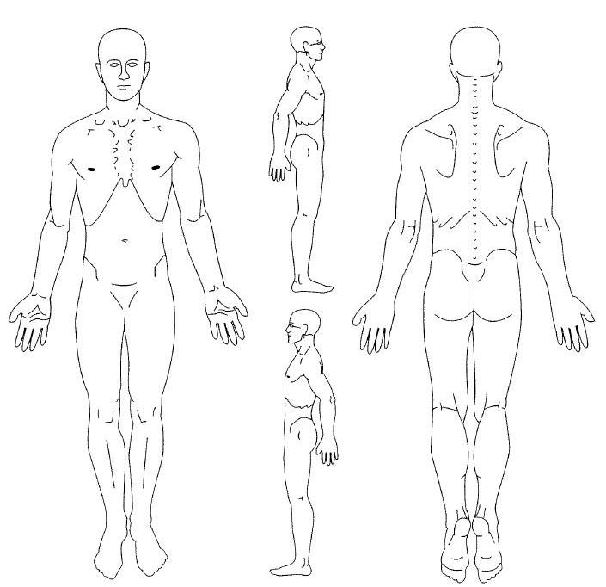
^^^ Aches
Numbness
Pins/Needles
XXX Burning
/// Stabbing
► Aggravating factors: what tends to worsen the problem or increase pain?: ______________________________________________
► Relieving factors: what tends to lessen the problem or decrease pain?: ________________________________________________
► Prior interventions: have you had any other treatment for this?: □ yes □ no
If yes, please check which treatment:
□ prescription medication □ OTC drugs □ homeopathic remedies □ massage
□ physical therapy □ surgery □ acupuncture □ chiropractic
► Is the problem worse at a certain time of day?: □ morning □ midday □ night □ comes and goes
Employment, ADL, and Recreation Information:
► Description of work: ______________________________________________________________________
► Condition's effect on work: □ no effect □ mild effect □ moderate □ severe
(no pain, can perform) (painful, can do) (painful, limited ability) (painful, cannot perform)
► Medical Conditions: check all that apply to you
□ arthritis □ cancer □ diabetes □ heart disease □ hypertension □ psychiatric illness □ skin disorder □ stroke □ headaches □ multiple sclerosis □ epilepsy □ gout □ hepatitis □ HIV/AIDS □ tuberculosis □ GI problems □ ulcer □ immune disorders
□ osteoporosis □ scoliosis □ neck pain □ back pain □ hip pain □ knee pain
□ foot pain □ shoulder pain □ TMJ pain □ anxiety □ depression □ blood disorder
□ dizziness □ numbness □ bruising □ high cholesterol □ asthma □ emphysema
□ pneumonia □ blurred vision □ hearing loss □ aortic aneurysm □ eczema □ low energy
□ kidney stones □ fainting □ fatigue □ sudden weight change □ psoriasis
□ other: _____________________________
► Surgeries: please list all surgeries and hospitalizations
□ spine □ pacemaker □ other: _________________________________________________________________
_________________________________________________________________
► Injuries: please list any significant traumas or accidents you have had in your lifetime
____________________________________________________________________________________________________
____________________________________________________________________________________________________
► Social History: check all that apply to you regularly
□ Caffeine Use □ Alcohol use □ Tobacco use □ Pain Reliever Use □ Exercise
► Family History: check all that apply
□ Arthritis □ Diabetes □ Heart disease □ Thyroid □ Depression □ Multiple Sclerosis
□ Cancer □ Stroke □ Hypertension □ Autoimmune □ Other: _______________________
► Medications/Supplements: please list all medications or supplements you currently take, and the reason for taking them.
____________________________________________________________________________________________________
____________________________________________________________________________________________________
____________________________________________________________________________________________________
____________________________________________________________________________________________________
► Imaging: have you had any recent x-rays, MRI's, or CT scans?: □ yes □ no if yes, of what? ____________________________

Acknowledgements
I may request a copy of the Privacy Policy and understand that it describes how my personal health information is protected and released on my behalf for seeking reimbursement from any involved third parties. I acknowledge that any insurance I may have in an agreement between the carrier and me that I am responsible for the payment of any covered or non-covered services I receive. To the best of my ability, the information I have supplied is complete and truthful. I have not misrepresented the presence, severity, or cause of my health concern.
Informed Consent
I have received information from my doctor about my condition and proposed chiropractic treatment program, including anticipated benefits, the reasonable foreseeable risks and side effects of the treatment, and alternatives to the proposed treatment, including no treatment. I understand that, as in all health care, there are some risks to chiropractic treatment. The risks include, but are not limited to, bruising, soreness, worsening of symptoms, muscle strains, sprains, fractures, dislocations, disc injuries, and strokes. I do not expect the doctor to be able to anticipate and explain all risks and complications, and I wish to rely on the doctor to exercise judgment during the course of the procedure which the doctor feels at the time, based upon the facts then known to him or her, is in my best interest. I have had the opportunity to ask questions about my condition and the recommended care. I understand that I may ask further questions at any time and wish to continue with chiropractic treatment.

If patient is a minor, print child's full name: _______________________________________________

x_______________________________________________________________ ____________________________
Patient Signature Date (MM/DD/YYYY)

